Multiple choice section

Question 1 [6.1]

Which of the following is the same as 23 cm?

A 230 m B 2.3 km C 2.3 mm D 230 mm

Question 2 [6.2]

The perimeter of a rectangle of length 4 cm and width 9 cm is:

A 26 cm B 13 mm C 36 cm D 26 mm

Question 3 [6.6]

Assuming that each cube represents 1 cm3, the volume of the following object in cm3 is:

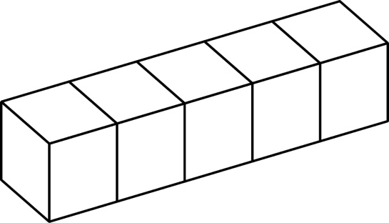

A 22 cm3 B 11 cm3 C 4 cm3 D 5 cm3

Question 4 [6.3]

A square of area 64 m2 has side length:

A 64 m B 32 m C 8 m D 16 m

Question 5 [6.3]

Which metric unit would be most suitable for measuring the area of a computer screen?

A mm2 B cm2 C m2 D km2

Question 6 [6.3]

|  |  |
| --- | --- |
| The shape has been drawn on centimetre grid paper.  What is its area?  A 30 cm2 B 15 cm2 C 56 cm2 D 16.5cm2 | PM7_SmB_TSa6_02 |

Question 7 [6.4]

A parallelogram with a base of 13 cm, and a height of 3 cm has an area of:

A 32 cm2 B 39 cm2 C 3.2 cm2 D 26 cm2

Question 8 [6.5]

A triangle with a base of 10 cm, and a height of 6 cm has an area of:

A 30 cm2 B 60 cm2 C 10 cm2 D 16 cm2

Multiple-choice total marks: \_\_\_\_ / 8

Short answer section

Question 9 3 marks [6.1, 6.2, 6.3]

Use words from the list below to complete the following sentences.

multiply divide height length multiplying

(a) To convert from a smaller unit of measurement to a larger unit, you \_\_\_\_\_\_\_\_\_\_\_\_\_\_\_\_\_\_\_\_.

(b) The area of a rectangle is calculated by \_\_\_\_\_\_\_\_\_\_\_\_\_\_\_\_\_\_\_\_\_ the length by the width.

(c) The perimeter of a square is calculated by multiplying its \_\_\_\_\_\_\_\_\_\_\_\_\_\_\_\_\_\_ by 4.

Question 10 3 marks [6.1]

Complete the following conversions.

(a) 19 km = \_\_\_\_\_\_\_\_\_\_ m (larger to smaller)

(b) 812 mm = \_\_\_\_\_\_\_\_\_ cm (smaller to larger)

(c) 799 mm = \_\_\_\_\_\_\_\_\_\_ m (smaller to larger)

Question 11 1 mark [6.1]

The Murray River is 2 375 000 m long. Convert this measurement to kilometres.

2 375 000 m = \_\_\_\_\_\_\_\_\_\_\_\_\_\_\_\_\_\_\_\_ km

Question 12 4 marks [6.2]

Find the perimeter of the following shapes.

(a) A rectangle with a length of 31 cm and a width of 1.4 cm.

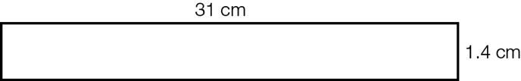

(b) A square with side lengths of 160 mm.

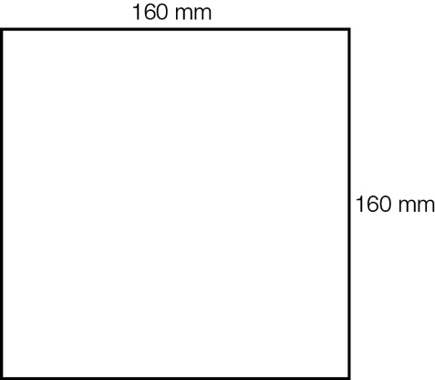

Question 13 2 marks [6.2]

Find the perimeter of the following shape by first finding any unknown sides.

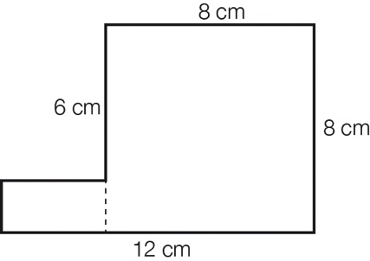

Question 14 2 marks [6.3]

Find the area of the following shapes. (Assume each square of the grid is 1 cm2.)

(a)

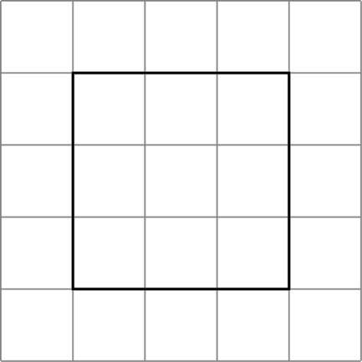

(b)

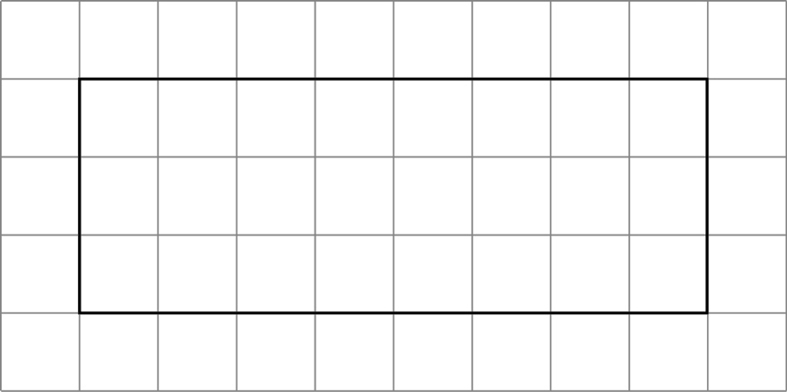

Question 15 2 marks [6.3]

Find the area of the following rectangle using the formula area = length × width.

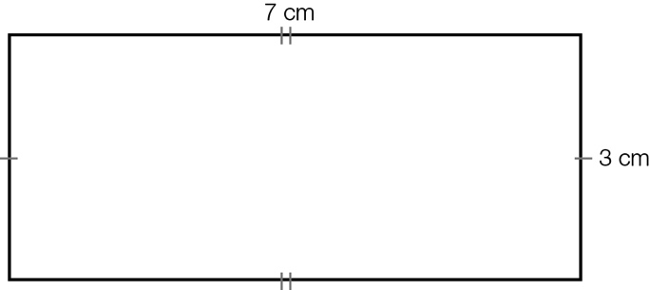

|  |
| --- |
| A = lw |
| =........ × ........ |
| = ............ cm2 |

Question 16 2 marks [6.3]

Find the area of the square with side lengths of 0.8 cm.

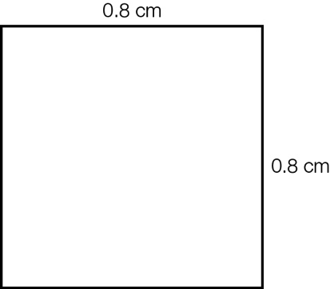

Question 17 2 marks [6.4]

Find the area of the parallelogram using the formula Area = base × height.

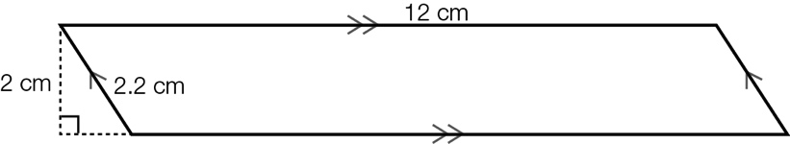

Question 18 2 marks [6.5]

Find the area of the triangle by using the formula Area = × base × height.

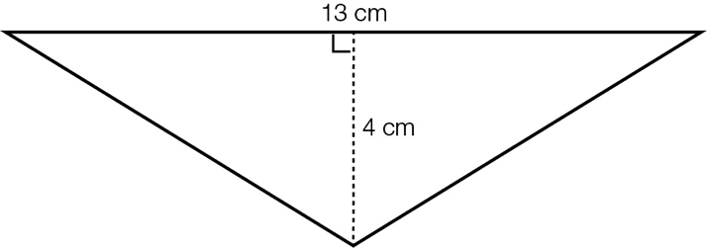

Question 19 1 mark [6.6]

Find the volume of the following. (Each small cube represents 1 cm3.)

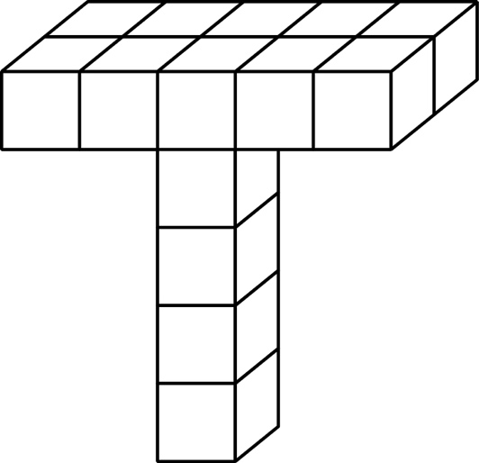

Question 20 2 marks [6.6]

Find the volume of the rectangular prism by using the formula:

Volume = length × width × height

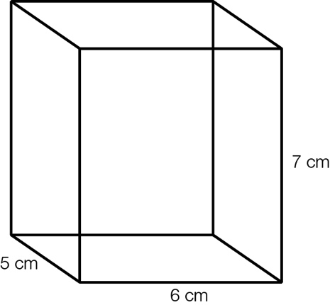

Question 21 3 marks [6.6]

A rectangular prism has a volume of 108 cm3.

If its length is 9 cm and its width is 6 cm, what is its height?

Draw a diagram.

Short answer total:\_\_\_\_\_\_\_\_\_/29

Extended answer section

Question 22 4 marks [6.5]

Find the shaded area.

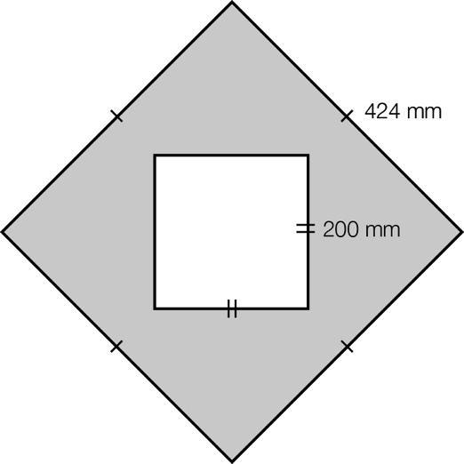

Question 23 4 marks [6.5]

Calculate the area by cutting the composite shape into a triangle and a rectangle.

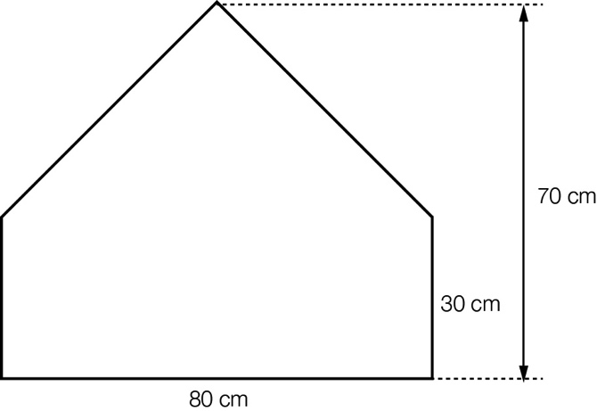

Extended answer total:\_\_\_\_\_\_\_\_\_/8

TOTAL test marks: \_\_\_\_\_\_\_ / 45